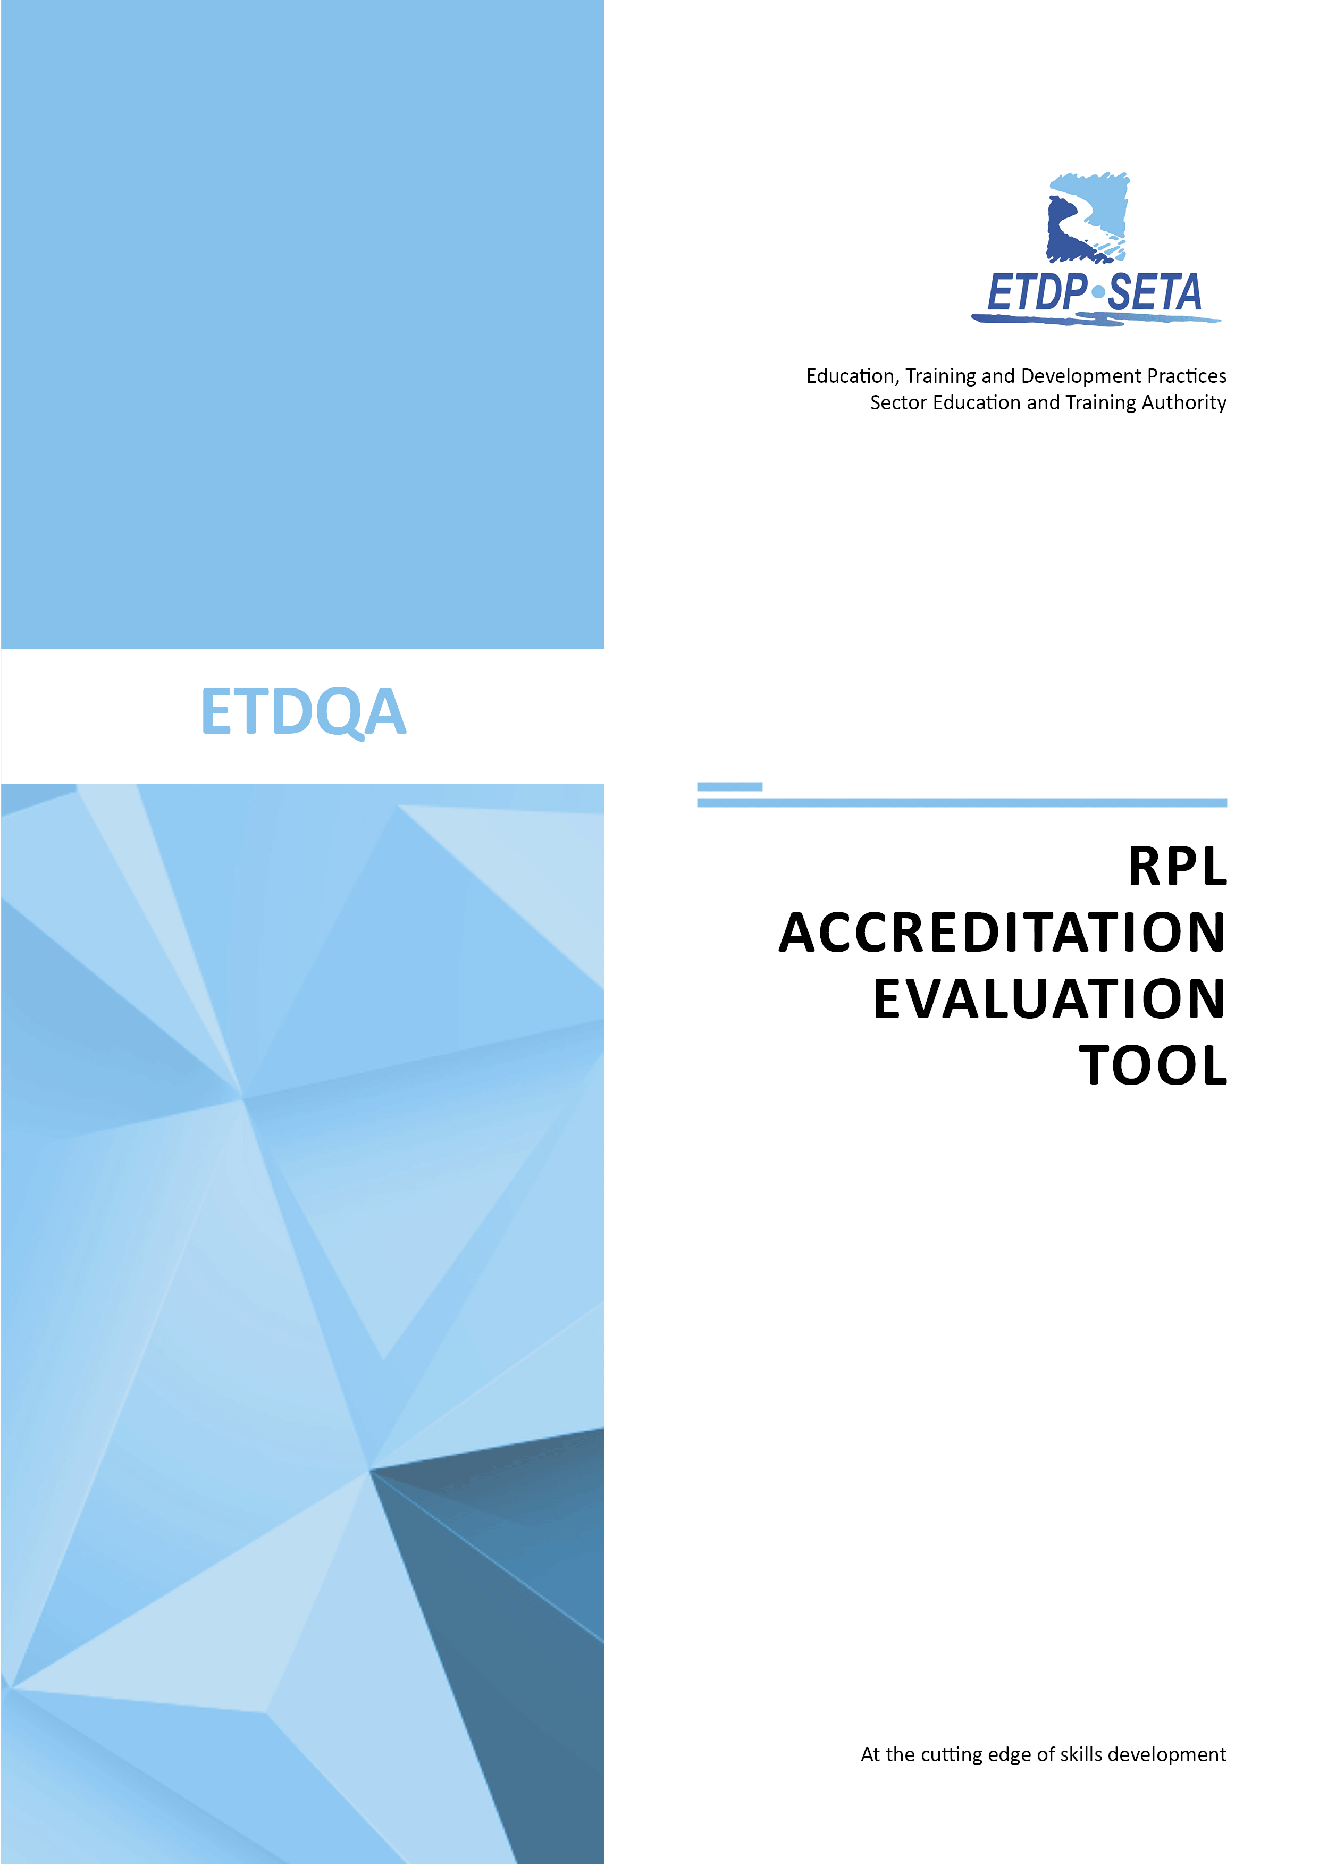

NAME OF PROVIDER
NAME OF QUALIFICATION
RPL TOOLKIT EVALUATION REPORT
DATE OF REPORT

Table of Contents

Table of Contents 2
A. Provider Details 3
B. Alignment Matrix 3
1. Qualification Details 3
C. RPL Toolkit Evaluation Judgement 4
D: RPL Toolkit Review 5
1. Submission for Evaluation 5
2. Alignment 5
3. RPL Clustering & Strategy 6
4. RPL Staff Resources 7
E. RPL Remedial Judgement 8

A. Provider Details

Registered Name of Provider:
Trading Name of Provider:
Company Registration Number:
Accreditation Status
Accreditation Number
Contact person:
Telephone Number
Fax Number
Mobile Number
Email Address
Type of Learning Programme
Date of Programme Submission
Submission (1st, 2nd, 3rd)

B. Alignment Matrix

1. Qualification Details
Name of Learning Programme / Qualification
ID Number
NQF Level
Credits
Rules of Combination
Registration Period
  REGISTRATION START DATE | REGISTRATION END DATE
Related Qualification/Unit standards

Type | ID | UNIT STANDARD TITLE | LEVEL | CREDITS | WHERE

C. RPL Toolkit Evaluation Judgement

The Programme Evaluator is required to provide an overall rating for each category of evaluation, and a final rating for the overall programme.

1 | No Evidence | 2 | Some evidence | 3 | Evidence but requires more work | 4 | Evidence meet the requirements | 5 | Good practice

No | Criterion Area | Overall Rating | No | Criterion Area | Overall Rating
1 | RPL Alignment |  | 4 | RPL Evidence Requirements / Activities
2 | RPL Entry / Orientation |  | 5 | Programme Quality Assurance
3 | RPL Process |  | 6 | ETD Staff Resources
OVERALL PROGRAMME RATING:

No | Criterion Area | Remediation

Evaluator Name
Evaluator Contact Details
Date of Programme Evaluation
Programme Status | Approved  Conditional Approval with Remediation  Not Recommended
Evaluator Comments and Recommendations
Evaluator Signature

D. RPL Toolkit Review

1. Submission for Evaluation

1 | No Evidence | 2 | Some evidence | 3 | Evidence but requires more work |  | 4 | Evidence meet the requirements | 5 | Good practice
Criteria |  | Evidence Requirements |  |  |  | Documents Included for Evaluation (list)
2.1  Programme Guides  included |  | - Alignment Matrix / Programme Strategy  - RPL Orientation Guide & Assessment Strategy  - RPL Advisor Guide / slides RPL Portfolio Guide  - RPL Assessment Toolkit

2. Alignment

1 | No Evidence | 2 | Some evidence | 3 | Evidence but requires more work |  | 4 | Evidence meet the requirements | 5 | Good practice
Criteria |  | Evidence Requirements |  |  |  | Rating | Evaluator Comments
2.2  Qualification Alignment |  | Qualification Details:  - Qualification name, level and purpose stated  - Credit value indicated and correct rules of combination outlined  - Unit standard selection in accordance with rules of combination
Entry Requirements:
- Occupation Details / Target population stated
- FETC 2nd language / CAT Policy
ELO Relationship:
- Exit Level outcomes / Qualification assessment criteria / unit standard relationship clear in clustering
- Essential embedded knowledge / CCFOs indicated

3. RPL Clustering & Strategy

1 | No Evidence | 2 | Some evidence | 3 | Evidence but requires more work |  | 4 | Evidence meet the requirements | 5 | Good practice
Criteria |  | Evidence Requirements |  |  |  | Rating | Evaluator Comments
3.1  Assessment Strategy |  | - Assessment approach clearly indicated  - Candidate activities’ alignment clearly indicated  - Emphasis is on historical evidence, and follows a holistic approach  - Summative activities planned offer variety i.e. theory, practical, historical / natural occurring evidence , and assesses foundational, practical, reflexive competence
3.2  RPL Process |  | - Candidate entry requirements clearly outlined  - Application, screening and assessment contract  - Assessment Planning and& Preparation  - Assessment time lines and post assessment support
3.3  Assessment Documents |  | - Assessment Guide – strategy, instructions on activities / methods / tools, administration required  - Assessment planning and preparation  - Assessment recording tools and re-assessment, feedback Assessment Judgement – activity – evidence – unit standard link  - Judgement in terms of VACS principle
3.4  Assessment Activities |  | - Emphasis on historical evidence  - Knowledge / practical split across unit standards  - Validity and sufficiency of Assessment Activities  - Authenticity and currency of assessment activities
3.5  Programme Quality Assurance |  | - Programme Guides - Formatting and editing, grammar and spelling, use of language, graphs and symbols Branding – use of logo, icons, standard template / blueprint,  - Version Control, headers and footers  - Resource recognition / acknowledgements, research appropriateness

4. RPL Staff Resources

1 | No Evidence | 2 | Some evidence | 3 | Evidence but requires more work |  | 4 | Evidence meet the requirements | 5 | Good practice
Criteria |  | Evidence Requirements |  |  |  | Rating | Evaluator Comments
4.1  Assessors |  | - Assessor expertise in line with qualification requirements  - Assessors registered with appropriate scope
4.2  Moderators |  | - Moderator capacity appropriate to assessment capacity  - Moderators registered with appropriate scope

E. RPL Remedial Judgement

The Provider is required to provide an overall rating for each category of evaluation, and a final rating for the overall programme.

1 | No Evidence | 2 | Some evidence | 3 | Evidence but requires more work | 4 | Evidence meet the requirements | 5 | Good practice

No | Criterion Area | Overall Rating | No | Criterion Area | Overall Rating
1 | RPL Alignment |  | 4 | RPL Evidence Requirements / Activities
2 | RPL Entry / Orientation |  | 5 | Programme Quality Assurance
3 | RPL Process |  | 6 | ETD Staff Resources
OVERALL PROGRAMME RATING:

No | Criteria | Remediation Required | Remedial Comments

Evaluator Name
Evaluator Contact Details
Date of Programme Evaluation
Programme Status | Approved  Not Recommended
Evaluator Comments and Recommendations
Evaluator Signature

- Conclusion

  - xxxxx has been awarded xxxxx, valid until xxxxx.
  - All conditions met in the report above will need to be maintained and improved in order to meet the requirements for accreditation.
  - You would be required to comply with the reporting procedures of SETQAA.
  - A Monitoring Site Visit will be conducted at least once during your period of accreditation, and you will be contacted prior to the visit.

Name of SETA Staff member:
Position:
E-mail Address:

