**Mapping practical tools that facilitate the implementation of work-based learning**

**in the Republic of Sudan[1]**

**Written Template Apprenticeship Contract’[2]**

|  |  |
| --- | --- |
| **Tool** | Written Template Apprenticeship Contract |
| **Tool focus** | This tool will introduce a simple-to-use template apprenticeship contract aimed at including informal Master Craftsmen more closely to an increasingly structured and less informal apprenticeship system |
| **Target group** | Public and private apprenticeship practitioners who are considering how to introduce written apprenticeship contracts to an informal apprenticeship.  Development projects looking to establish standard practices in the delivery of informal training models.  Policy makers looking to establish basic guidelines and requirements for the delivery of training in the informal sector. |

**The Programme: Apprenticeships in Sudan[3]**

In 2001 the Vocational Training and Apprenticeship Act was issued in accordance with the Constitutional Decree dated and passed by the National Assembly.[4] This Act saw the introduction of regulations, overseen by Supreme Council for Vocational Training and Apprenticeships (SCVTA) that created a legal framework governing the delivery of apprenticeships.[5]

Some **formal apprenticeship** programmes are offered as part of the TVET system, including three-, two- and one-year programmes. In this model, basic education graduates under the age of 20, may apply for a three-year apprenticeship programme offered at vocational training centres (VTC) equal to a total of 3,870 hours (1,000 hours per year for two years, then 1,650 hours for in-company training (42%) and 220 hours at the VTC in the third year). After completing three years, trainees may sit for the standardised apprenticeship diploma exam after which they can enter the labour market as skilled workers. Graduates may also enrol in technical colleges or even universities if they pass the qualifying exam[6]. Students who have not passed the basic education exam can join other training courses at VTCs. This may be on one of two apprenticeship programmes or short training courses:

* A two-year apprenticeship programme which has a total of 2,200 hours (800 hours per year for two years and 600 hours of in-company training divided equally over two years).
* A one-year apprenticeship programme which has a total of 1,100 hours (800 hours at the Vocational Training Centre and 300 hours in in-industry training).

In Sudan, as in many other African countries, **informal apprenticeships[7]** make up the main source for skills development and are often the only realistic skills training opportunity for many young Sudanese. Compared to the formal sector, the informal sector has a much higher absorption capacity for young people entering the labour market. Informal apprenticeships are often delivered by family/friends (traditional apprenticeship) or local artisans through micro, small, and medium enterprises -MSMEs- (informal apprenticeship). These informal training models are typically responsive to the short-term skills needed in the local economy/community, which is in contrast to the formal TVET system that tends to be more supply-driven and often lacks relevance to industry skills demand.

Despite the capacity of informal apprenticeships to offer training to a large number of trainees (directed at immediate skills needs), it is a model that comes with significant limitations. There are concerns about quality, as the apprentices may not be able to develop competencies beyond those held by the master craftsman, who themselves may have gained their skills through informal apprenticeships. It also limits the opportunities for trainees to develop wider knowledge which is increasingly important as jobs become more technologically driven and fluid. These quality issues will have a negative impact on business productivity and innovation, and trainees’ long term sustainable transition to employment. Informal apprenticeships can also be defined by an absence of agreed training programmes and contractual arrangements between the master craftsperson and the apprentice. This can result in exploitative conditions of long working hours and low pay, which borders on cheap labour and, in some cases, can result in child labour concerns.[8]

According to findings of an ILO study (2014)[9] over 75% of informal apprentices were hired based on a verbal agreement and less than 4% had a written contract. The apprenticeship period varied from 1 to 60 months, often based on how quickly apprentices were able to acquire skills. Most apprentices work more than eight hours a day, seven days a week. In general, no training fees were paid for the training, instead, apprentices would receive wages, often infrequently, or pocket money for their work and tips from customers. These characteristics are believed to represent some of the challenges faced by informal vocational education and training in other African countries.

The ILO study also made a series of recommendations for improving the Sudanese apprenticeship system[10]:

* Support efforts aimed at improving informal apprenticeships, within the basic pillars of the informal system
* Ensure the application of the fundamental principles and rights at work in all sectors
* Improve basic development services and working conditions, including minimum working hours
* Introduce financial incentives to build capacity for informal training
* Continuous improvement of curricula, materials, equipment and trainer capacities
* Supplement traditional informal training with off-the-job training
* Promote health and safety measures to mitigate hazardous work conditions
* Upgrade programmes needed for both master craftsmen and apprentices
* Involve social networks, trade unions and business associations in improving informal apprenticeships
* Quality assurance through training standards setting, skills recognition and enforcing contracts
* Promoting access to informal apprenticeships for young women to overcome gender gaps.
* Introduction of rules and standards to assure the quality of training enforced through apprenticeship contracts
* Facilitate informal apprenticeship graduates to participate in formal trade testing and certification systems
* Build on the strengths of informal apprenticeships and eliminate their shortcomings
* Encourage initiatives to combat child labour and youth unemployment, to boost employability, income opportunities and decent work for many young people in Sudan

The introduction of the described tool can be seen as a direct response to supporting the implementation of these key recommendations.

**The Tool: Human Resource Pioneer Firm Certification System – Apprenticeship Contract**

**Introduction**

The tool that this report highlights - ‘Apprenticeship Contract’ - is drawn from the ‘[Human Resource Pioneer Firm Certification System’](https://drive.google.com/drive/u/0/my-drive) (‘the certification system’) initiative. The certification system initiative is also described in this study.

The certification system was developed through the employment sector strand of the Japanese International Cooperation Agency (JICA) ‘[Strengthening peace through the improvement of public services in three Darfur states’](https://www.jica.go.jp/sudan/english/activities/c8h0vm0000a33fpg-att/activity03_11_01.pdf) (SMAP – II) project (May 2015 – Nov 2020). SMAP-II aimed to enhance the peace and stability of Darfur through improvement of the public services in four key areas: health, rural water supply, employment and monitoring and evaluation of the public projects. Project activities included conducting pilot projects with an awareness of promoting peace, strengthening the capacity of state government officials, and improving the system for providing administrative services such as the development of guidelines and manuals.

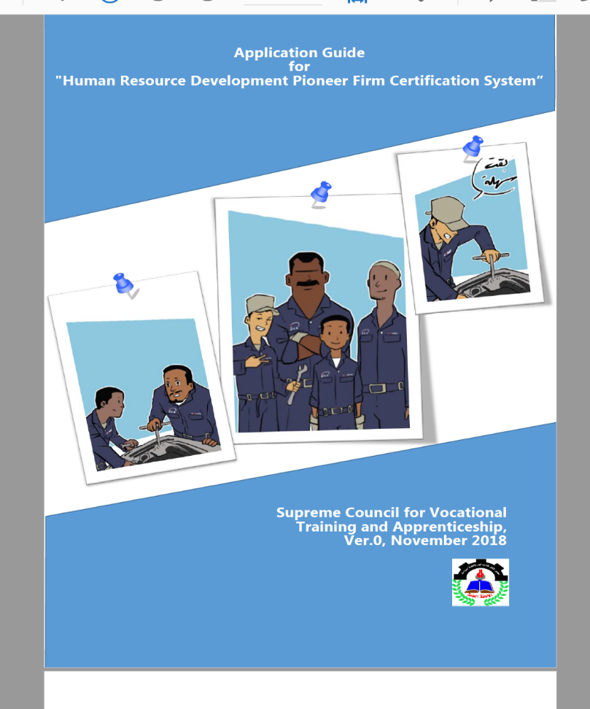In the employment sector, SMAP-II conducted three vocational training pilot projects, the apprenticeship contract tool and certification system initiative, described in this study, were developed through the second pilot work stream: ‘**Human resource development for micro and small enterprises’**, delivered through the Craftsman Union (CU) via a one-year training programme for workshop owners and master craftsman (a total of 120 enterprises) to provide know-how on staff training (including apprenticeships) as well as business management skills. SCTVA was the Government of Sudan’s delivery agency for this intervention.[11]

The certificate system has been designed to validate enterprises who satisfy the minimum requirements of an effective in-service training provider to be certified as “Human Resource Development Pioneer Firm” by SCVTA. The core objective of the certification system is to provide a mechanism to register and promote enterprises who are consciously and conscientiously training their employees and, by doing so, promoting decent work and improving the social images of workers in MSME industries.

**The Written Template Apprenticeship Contract**

The presented tool is a template for an apprenticeship contract that is included as an annex in the certification system’s employers’ guide[12]. The contract covers key areas of agreement that need to be established to secure a quality apprenticeship experience, for all stakeholders. This includes: training plan, commitment to off-the-job training, certification, health and safety, minimum pay and conditions and access to resources. It also references apprentices’ obligations around commitment to training, employers’ rules and respecting the workplace and equipment.

**Template Apprenticeship Contract**

|  |
| --- |
| **Apprenticeship contract**  On the date -------------------------------------------------------------------------------------------- -an agreement has been concluded between -------------------------------------------------------------------------------------------------------------------------------------------------the owner of the (------------) workshop (hereinafter known as the first party) and the apprentice ----------------------------------------------------------------------------------------------  (Hereinafter known as the second party) on that the first party will accept to enrol the second party as an apprentice at his workshop to acquire the knowledge, skills and good work attitudes in the occupation of -------------------------for a period of --------------months as of the date of the signature of this contract.  **The Master craftsman (MC) will be committed to:**   * Provide the on-the-job training of a trade according to a training plan prepared and agreed upon by the MC and the apprentice; * Enable the apprentice to acquire practical skills by providing access to necessary equipment and tools; * Allow the apprentice to attend the off-the-job training without any cuts of the wage, according to a training plan prepared and agreed by the MC and the apprentice; * Issue the apprentice upon completing the apprenticeship a certificate of attendance specifying the apprenticeship duration and the level of skills attained; * Inform the apprentices of occupational hazards and means of protection against such hazards, and take the necessary precautions to protect apprentice against industrial accidents and occupational diseases; * Not assign a worker to perform a job before providing him with enough training or before making him work under the supervision of one or more experienced persons in the field; * Pay the apprentice a monthly pay not less than the minimum wage specified by the government.   **The apprentice will be committed to:**   * Actively participate in the on-the-job training organized by the MC; * Attend the off-the-job training organized by CU; * Refrain from performing any act which may expose him or the others to danger and be obliged to use every means of protection provided to him by the MC; * Not intentionally damage or misuse the equipment, tools, materials, and other belongings of the workshop; * Observe and strictly follow the regulations and the system of work of the workshop.   **Name of the MC: --------------------------------------------------------------------------------------**  **Signature of the MC: ---------------------------------------------------------------------------------**  **Name of the apprentice: ----------------------------------------------------------------------------**  **Signature of the apprentice: -----------------------------------------------------------------------** |

The apprenticeship contract provides a template that can be used by master craftsmen and their apprentices in establishing a basic agreement for the apprenticeship period. The introduction of practical tools supports Sudanese employers’ involvement in the certification system by making it more accessible, and reducing concerns that it could be administratively burdensome and regulatorily prohibitive. It is worth noting the parallels between the concepts reinforced through this contract and the referenced ILO recommendations for developing Sudan’s informal apprenticeships. This includes looking to improve models of informal apprenticeships within existing structures.

The contract can also be seen as making a contribution to recommendations regarding promoting fundamental principles of the rights at work, including in regards to minimum pay and health and safety. It also looks to define quality training, including off the job and input from wider stakeholders, in this case, the Craftsmen Union.

**Pros and Cons**

**Pros**

* The beauty of the template apprenticeship contract lies in its simplicity, which is aligned with the realities of the delivery of apprenticeships in Sudan. This is characterised by a large informal sector and associated informal apprenticeships. The introduction of a complicated apprenticeship contact that attempts to cover every minutia of the relationship could be counterproductive in inhibiting employers with engaging with the system. Instead, this template contract takes its point of departure from the realities of training in the informal sector and encourages, through a bottom-up approach, rather than a top-down imposition of areas for contractual agreement. The contract must therefore be seen as a tool that is ‘fit for purpose’ and part of a process aimed at bridging the gap between informal and formal apprenticeships.
* The apprenticeship contract is aligned with the wider certification system and application guide in providing a practical and accessible tool. It acknowledges that contractual arrangements could be complicated for many informal sector master craftsmen and the attempt to ‘demystify’ them through a clear usable format will help to address these concerns. The tool also clearly aligns with the recommendation of capacity building informal practices within the current ‘pillars’ that define the sector. To some extent, the described contract could be seen as a written version of existing oral agreements.
* The use of the contract to capture training plans and agreed roles and responsibilities will be an excellent channel through which to monitor apprentices’ activities and progress. This clear documentation of the tenets of their programme will give them a greater sense of direction, professional self-confidence and discipline.
* The contract references key criteria for a quality apprenticeship in terms of developing knowledge, skills and work attitudes. It also emphasises that these outputs need to be developed through training plans: *‘Provide the on-the-job training of a trade according to a training plan prepared and agreed upon by the MC and the apprentice’*. This will promote planned programmes and allow the development of a broad range of apprentices’ competencies, not limited solely to the technical application of job tasks. It is also important to note that apprentices’ skills will be captured through ‘certificate of attendance’ recording the duration of their training and level of developed skills: *‘Issue the apprentice upon completing the apprenticeship a certificate of attendance specifying the apprenticeship duration and the level of skills.’* This will support apprentices’ employability and transferability of their training, and the growing regulation of informal apprenticeships within the confines of the informal sector.
* Introducing and formalising off-the-job training, including insurances around apprentices’ pay for attending training (*‘Allow the apprentice to attend the off the job training without any cuts of the wage*’), will mean that apprentices have opportunities to learn beyond the direct confines of their workplaces. This will support the development of broader employability skills and knowledge beyond that of the mentoring master craftsmen.
* The contract also introduces concepts of rights at work. This includes the reference to occupational health and safety: ‘*l take the necessary precautions to protect apprentice against industrial accidents and occupational diseases*’, which directly aligns the effect of the contract with the recommendations to eliminate hazardous working conditions. This contract's commitment to improving basic working conditions is also reflected in the clause that refers to: *‘Pay the apprentice a monthly pay not less than the minimum wage specified’*.
* The contract also defines apprenticeship roles and responsibilities, with master craftsmen being assigned responsibility for developing training plans and supervising apprentices, and apprentices expected to take a proactive approach to the training organised by their employers*: ‘Actively participate in the on-the-job training organized by the MC.’*
* A key feature of the contract is that it captures obligations from both the side of master craftsmen and their apprentices. If MCs are expected to develop training plans and deliver on the job training, then apprentices are expected to proactively engage with the development of their skills, knowledge and attitudes. If employers are obliged to provide equipment, then apprentices are expected to respect and look after it. If MCs are mandated to provide safe working environments, then apprentices need to follow health and safety guidelines. This mapping of obligations will help to establish a sense of partnership which will strengthen the collaborative foundation on which good apprenticeships are built and will challenge some of the exploitative arrangements which can define informal training models.
* Although the contract is deliberately ‘light touch’ and non-binding, the fact that it is part of a wider scheme overseen by government agencies, SCTVA, and trade bodies, Craftsmen Union, means that it has some significance that will help formalise informal agreements.
* The contract is an important first step in capturing the key criteria for quality training and introducing formal and agreed activities in Sudan's informal sector training mediums.

**Cons**

* The contract’s flexibility and lack of legally binding clauses is a sensible approach which will encourage MCs to engage with the scheme. However, it does mean that it could be open to abuse and still result in exploitative working arrangements. Consequently, the initiative for the certification scheme and the ongoing sensitisation of partners to this tool, as well as the monitoring of its use and impact, are important for the deliberate process towards improved apprenticeships.
* With that in mind, the contract does not reference all key areas in relation to rights at work, for example, there is no clause related to hours, number of days of the week worked or any paid/unpaid leave entitlement. Neither does it give any details on contract termination or notice period.
* There is no reference to any requirements or quotas to promote GESI access and inclusion. A point underlined by the use of the masculine pronoun in one of the sentences *‘.... training or before making him work under the supervision....’* This could be a result of the translation from the original Arabic.

**Testimonials**

As described in the report outlining the Certification System initiative, there was a programme review conducted in 2017 on the first roll-out of the certification system, which identified some interesting insights, testimonials and examples of its impact[13]. This included some that can be more directly related to the apprenticeship contract tool:

* There were reports of improved skills, attitudes and discipline resulting from the design and delivery of more formalised and regulated apprenticeship programmes developed through the scheme.
* Apprentices showed increased motivation based on the financial and working condition improvements derived from the contractual agreements developed through the scheme. Employers also reported improved apprenticeship commitment to their businesses, discipline and adherence to rules: ‘***Ibrahim Hussein****, owner of a welding workshop, said that the contracts have improved the self-confidence of the apprentices and improved their productivity.’*
* The contract also provided a valuable tool to monitor apprentices progress and allow wider stakeholders to engage in the process: *‘The contract created shared follow up and monitoring between the workshop manager and the apprentices’ family thus improving commitment towards the business rules and discipline.*’
* Apprentices also showed more interest in completing training programmes. This improved retention was attributed to reasons linked to certification, finances and an increased sense of obligation to their employers.
* Employers reported the positive impact on productivity resulting from payment incentive schemes, which would have been captured through contractual agreements.

**Bibliography**

* Application guide for the human resource pioneer firm system <https://drive.google.com/drive/u/0/my-drive> SCTVA
* Guide to the Vocational Training System in Sudan’ Supreme Council for Vocational Training and Apprenticeship 2021. [www.scvta.gov.sd](http://www.scvta.gov.sd)
* ILO Skills Development in Sudan (2014) ‘The Formal and the Informal Reality’ <https://www.ilo.org/africa/information-resources/publications/WCMS_243636/lang--en/index.htm>
* ILO Sudan TVET Policy 2013 <https://www.ilo.org/wcmsp5/groups/public/---africa/---ro-abidjan/---sro-cairo/documents/publication/wcms_243649.pdf>
* ILO/UNDP (2014) A Road Map Towards a National Employment Policy for Sudan <https://www.ilo.org/global/docs/WCMS_334878/lang--en/index.htm>
* Ministry of Education. [http://www.moe.gov.sd/talimphani.html#](http://www.moe.gov.sd/talimphani.html)
* Ministry of Higher Education and Scientific Research. <https://mohe.gov.sd/index.php>
* Promoting entrepreneurship and employment in Khartoum State GIZ 2022 <https://www.giz.de/en/worldwide/93699.html> (last accessed 14.03.2022)
* SMAP-II completion report, JICA, February 2021 <https://openjicareport.jica.go.jp/pdf/12357679.pdf>
* SMAP-II Wrap up workshop, JICA, Consultant Report (August 2017)
* SMAP-II, JICA, summary pdf <https://www.jica.go.jp/sudan/english/activities/c8h0vm0000a33fpg-att/activity03_11_01.pdf>
* Sudan education system <https://unevoc.unesco.org/home/Dynamic+TVET+Country+Profiles/country=SDN>
* Supreme Council for Human Development and Labor <http://mhd.gov.sd/%d9%86%d8%a8%d8%b0%d8%a9-%d8%aa%d8%b9%d8%b1%d9%8a%d9%81%d9%8a%d8%a9-%d8%b9%d9%86-%d8%a7%d9%84%d8%aa%d8%af%d8%b1%d9%8a%d8%a8-%d8%a7%d9%84%d9%85%d9%87%d9%86%d9%8a/>
* The Project for Strengthening Vocational Training System of State Vocational Training Centers, JICA, 2020 [www.jica.go.jp/sudan/english/activities/c8h0vm0000a3itxd-att/activity03_15_01.pdf](http://www.jica.go.jp/sudan/english/activities/c8h0vm0000a3itxd-att/activity03_15_01.pdf)
* UNESCO ‘TVET Policy Review Sudan’ (2016)
* UNESO ‘Building Sudan’s New TVET strategy’ (2020) <https://en.unesco.org/news/building-sudans-new-tvet-strategy>
* UNIDO <http://mhd.gov.sd/%d9%86%d8%a8%d8%b0%d8%a9-%d8%aa%d8%b9%d8%b1%d9%8a%d9%81%d9%8a%d8%a9-%d8%b9%d9%86-%d8%a7%d9%84%d8%aa%d8%af%d8%b1%d9%8a%d8%a8-%d8%a7%d9%84%d9%85%d9%87%d9%86%d9%8a/>
* UNIDO, [Report of the Project Inception Phase Employment and Entrepreneurship Development for Sudanese Migrant Youth, Refugees, Asylum Seekers and Host Communities in Khartoum State (2017)](https://open.unido.org/api/documents/12975503/download/Final%2520Draft%2520Inception%2520Report%2520(Nov.%252016%25202017).pdf)

1. Through this paper, the African Union abbreviation – Sudan – will be used.
2. Disclaimer: This publication was produced with the financial support of the European Union and the German Federal Ministry for Economic Cooperation and Development. The views and opinions expressed herein are those of the authors or persons cited and do not necessarily reflect the official policy, view or position of AUDA-NEPAD, the European Union or the German Federal Ministry for Economic Cooperation and Development. The terms used herein and the presentation of material therein do not imply any endorsement by AUDA-NPAD, the European Union or the German Federal Ministry for Economic Cooperation and Development. Information in this book is offered in the understanding that it does not contain legal, financial or other forms of professional advice. Although the author has made great efforts to ensure the accuracy of the content, errors and omissions may occur.
3. The presentation of apprenticeship in Sudan is based on ‘Guide to the Vocational Training System in Sudan’ Supreme Council for Vocational Training and Apprenticeship 2021. http/ /www.scvta.gov.sd
4. 'Vocational Training and Apprenticeship Act (2001)'. The Republic of Sudan. Ministry of Labour, Public Service and Human Resources Development, Supreme Council for Vocational Training and Apprenticeship, General Secretariat. Khartoum 2007
5. For a full account of the legal framework governing apprenticeship see ‘Guide to the Vocational Training System in Sudan’ Supreme Council for Vocational Training and Apprenticeship 2021. http/ /www.scvta.gov.sd
6. ILO Skills Development in Sudan (2014) ‘The Formal and the Informal Reality’
7. For a more detailed account of informal apprenticeship in Sudan see ’Skills Development in Sudan. The formal and the informal reality’ prepared by Ibrahim Khalid Ibrahim, Abdel Moneim Hussein Mahmoud, Marcus Powell, Huyam Abdelrahim. ILO 2014. <https://www.ilo.org/wcmsp5/groups/public/---africa/---ro-abidjan/---sro-cairo/documents/publication/wcms_243636.pdf> Although the finding dates back to 2014 the main findings and observations are very likely still valid.
8. ’Skills Development in Sudan. The formal and the informal reality’ prepared by Ibrahim Khalid Ibrahim, Abdel Moneim Hussein Mahmoud, Marcus Powell, Huyam Abdelrahim. ILO 2014. <https://www.ilo.org/wcmsp5/groups/public/---africa/---ro-abidjan/---sro-cairo/documents/publication/wcms_243636.pdf>
9. Ibid
10. Ibid
11. SMAP-II completion report, JICA, February 2021 <https://openjicareport.jica.go.jp/pdf/12357679.pdf>
12. Application guide for the human resource pioneer firm system <https://drive.google.com/drive/u/0/my-drive>
13. SMAP-II Wrap up workshop, Consultant Report (August 2017)