**Mapping practical tools that facilitate the implementation of work-based learning**

**‘Field attachment – Apprenticeship Logbook’[1]**

|  |  |
| --- | --- |
| **Tool** | Field attachment – Apprenticeship Logbook |
| **Tool focus** | This tool is aimed at supporting the learning of the trainees during their learning period at companies through recording work/learning tasks and assessing how the trainees performed these tasks and performed in general. |
| **Target group** | The tool will be of interest to TVET institutions sending their trainees on field attachments or implementing dual apprenticeship programmes.  Companies taking on a trainee or an apprentice (intern) will find the tool interesting to organise and structure their engagement with the trainee/apprentice.  Trainees and apprentices (interns) can use the tool to manage and structure their learning. The tool will also be important in assessing their learning results as an integrated part of graduation and could be used when approaching prospective employers. |

**Description of the programme**

Many formal TVET systems in Africa are offering industrial attachments to their students. Industrial attachments link industry and TVET institutions for placing students at the workplace for the acquisition of practical skills and appropriate work ethics.

Attachment of students to companies during part of their training is a training methodology which philosophical basis revolves around experiential learning theory. The underlying understanding is that practical experience plays a crucial role in the learning process and in building competencies. In this context, industrial attachment forms part of work-based learning (WBL) such as internship and apprenticeship.

In many cases, such as in Tanzania, we see that industrial attachment is an integrated part of the formal curricula. For example, the VETA ‘Packed Curriculum for Welding and Fabrication Short Course’ includes industrial attachment, which is termed field attachment:

*‘Normally, the vocational teacher functions as a facilitator - hence learning and training is learner centred. Learning and training however will include institutional and industrial based training (Field Attachment). Field Attachment will be part of the training. Its assessment modalities will be managed by using a logbook comprising occupational areas to be covered.’*

The curriculum goes on to describe:

***‘Field Attachment***

*The period of field attachment is 8 (eight) weeks. During the field attachment, the vocational teachers should visit the trainees at least once to ascertain the learning and training performances.’*

Source: Packed Curriculum for Welding and Fabrication Short Course. VETA 2013

Furthermore, industrial attachment periods may be a prerequisite for taking the final examinations and awards. This means that a minimum pass mark may be introduced and that the attachment thereby is compulsory for every student.

As mentioned in the above reference, it is the responsibility of the vocational teachers to visit the trainees at least once during the field attachments. Ideally, the logbook should help maximise the value of instructors’ visits and, by doing so, ensure that learning is progressing. However, financial resources enabling vocational teachers to visit the trainees might not be available, which makes the logbook all the more important. This is not to say that the logbook can substitute instructors’ visits.

**Description of the tool: Field Attachment Logbook**

**What is a logbook?**

A logbook is a practical tool used during field attachment, internship or dual apprenticeship periods at the company. Well-structured and applied logbooks can indicate the accomplishment of a list of tasks. Logbooks can record a trainees’ day to day work and learning activities and also the competencies he/she attained or achieved. If maintained properly, a logbook provides a comprehensive account of what the trainee has done and learned on a daily or weekly basis.

Logbooks facilitate communication between the trainee, the workplace instructor and the visiting vocational teacher. They help to structure and standardise learning at the workplace especially if multiple sites are involved. Standardisation of logbooks can increase the number of performed tasks. A standardised logbook can include tasks which might be overlooked at the workplace: This can ensure that the learning is in accordance with the requirements of the curriculum considerations and that routine tasks are avoided. A review of the logbooks can reveal weak points of training and can evaluate whether trainees have fulfilled the minimum requirements of training. It can also show the strength of the trainees, especially if including comments on the quality of the performed tasks compared to only mentioning that a task was performed. In turn, this can be used by the trainee to demonstrate competencies to prospective employers.

If a logbook has fixed tasks to be achieved during the field attachment, it can provide a clear set of learning objectives and give vocational trainers and workplace instructors an overview of the requirements of training and assessment as well as the learning progress. The passage below from a logbook is an example of this.

Source: Bricklayer - Internship Log Book The National Trade Committee for the Education of the Bricklayer, Stonemason and Stucco Worker Trades. <https://www.bygud.com/education-and-training/educations/bricklayer/logbook/>

**Application of logbooks in work-based learning (WBL)?**

Logbooks can be applied across different WBL models, including both apprenticeships and industrial attachments, as illustrated in the following infographic. The first example is a programme where field attachment (or industrial attachment) is offered towards the end of the programme. This is why the logbook is used during the field attachment period. The second example shows a dual apprenticeship programme applying the block release method where the logbook is used during the periods where the apprentice is at the company.

**The content of the VETA logbook**

The logbook used by VETA has an introduction which provides an overview on how it should be used. This includes reference to the requirements for signed daily entries

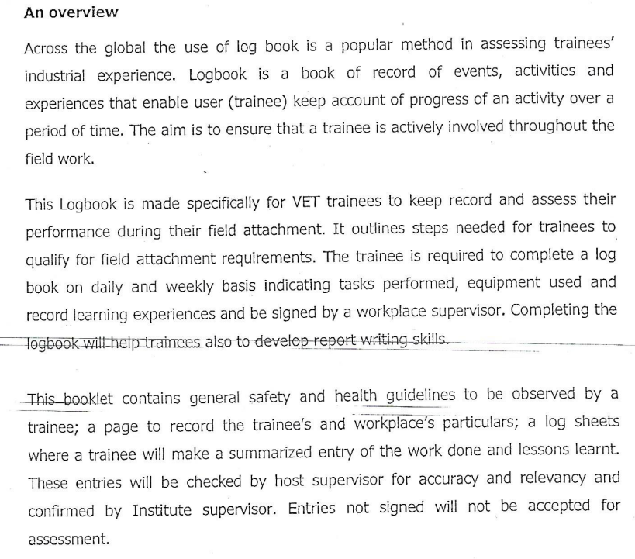

Source: VETA Logbook

The logbook’s first page (trainees and workplace’s particulars) has all the necessary trainee contact details. On the first page of the logbook, all contact information must be entered for the trainee, company supervisor and contact persons from the TVET institution. It also has a section where observations and comments to the trainee can be made. On the following page, the host supervisor should enter his/her contact details.

This is followed by ‘Trainees General Placement Safety Induction’ which is a list of 12 points that the trainee should be aware of such as: fire exits and processes, location of fire extinguishers, first aid facilities, personal protective equipment and also housekeeping regarding toilet facilities and where the trainee may eat and drink.

The following pages are where the actual work and learning activities are to be entered. There is one page for each week. It is interesting to see that the trainee should mention the lesson learned for each day which will facilitate their constant professional reflection and development.

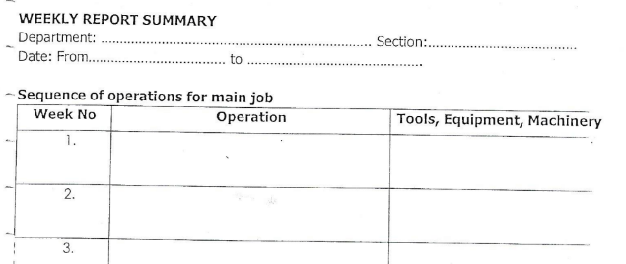As the name indicates, the ‘Weekly Report Summary’ page is to be used to enter all the weekly activities. As can be seen from the below, the entries are different from those recorded on the weekly pages.

Source: VETA Logbook

The last page is a ‘Programme Assessment Form’ used to assess the trainees’ field visits according to general assessment criteria and field attachment specific assessment criteria. Source: VETA Logbook

The example of a programme assessment form shown overleaf was filled during a field attachment at Tanzania Port Authority of an electrical installation trainee. The assessment form is divided between the general assessment criteria and the written specific assessment criteria relevant to the specific field attachment. The general assessment criteria are related to the curriculum as is the weight of marking. This shows which soft skills are considered important. For example, innovation/creativity can give 15 points while the speed of learning is only given 5 points. In a constant dialogue with employers it is established that general assessment criteria and their relative weights may change and thereby stay relevant.

The logbook is signed by the host supervisor and the TVET vocational teacher to verify the entries in the logbook.

As previously mentioned, field attachments are integrated parts of the vocational programmes, which is why the score from the logbook recorded assessment counts in the final assessment of the trainee.

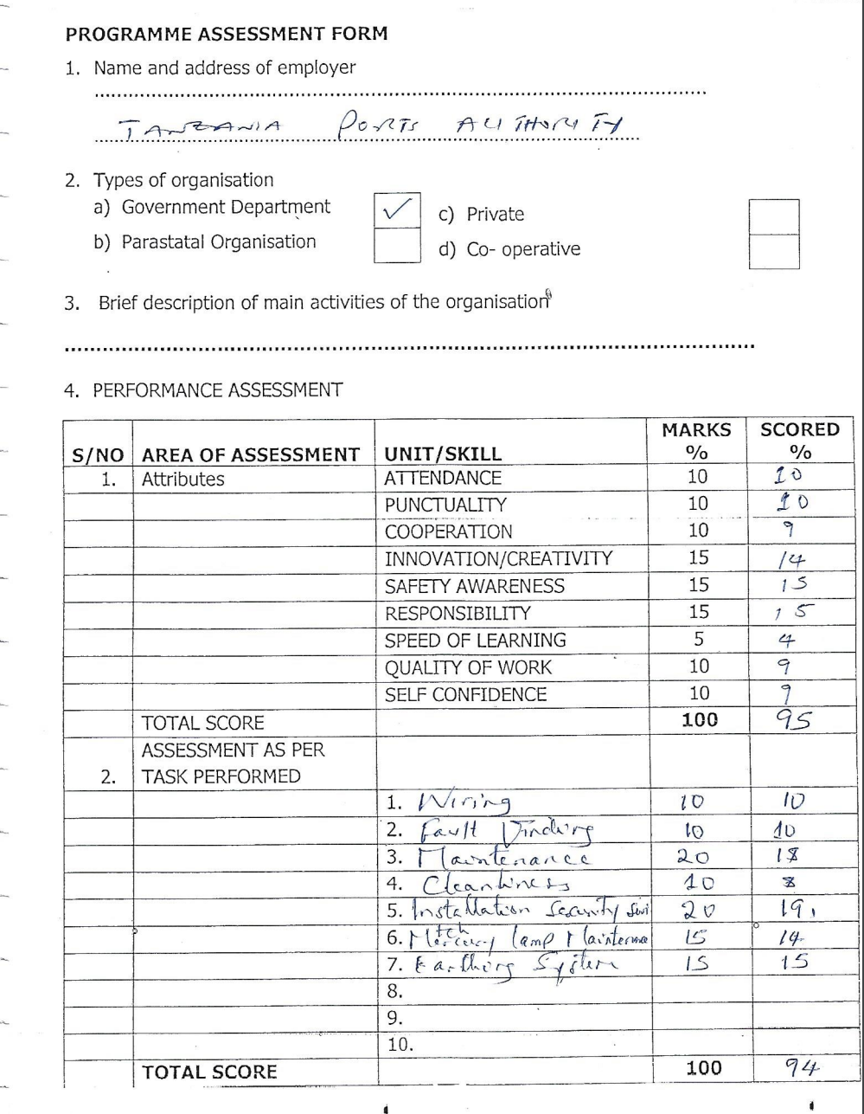

Source: VETA Logbook

**Paper or digital logbooks?**

As the internet becomes more widely available a natural progression will be towards the digitalisation of logbooks. As with many other documents and records they are now digital, there are advantages associated with record-keeping that can be taken for granted. However, it will still be important to monitor the transition to digital formats to understand the emergence of advantages and constraints that impact on the final assessment of the trainees.

Below is a rough list of advantages and constraints of both a paper and digital version of a logbook which may be helpful when considering introducing digital logbooks.

|  |  |  |
| --- | --- | --- |
| **Paper version** |  | **Digital Version** |
| **Advantages** |  | **Advantages** |
| Entries not made at the due date could still be made |  | If the logbook is not locked after a certain due date, entries not made at the due date could still be made |
| Entries could be made with ease as this does not depend on internet connectivity |  | Learning experiences could be presented in a different way than in writing for example a video showing a task being performed. |
| The logbook is in principle always accessible |  | It is easier to develop or adjust the logbook to suit the specific vocation/sector needs as they change |
| It is a well-established system which the TVET stakeholders know how to manage |  | A digital logbook can be kept well and can be retrieved or deleted as agreed |
| The logbook can be used to show competencies toward employers |  | Co-creation of knowledge and resources among trainees is possible |
| Digital storing of logbooks will likely be easier and increase their use of them as they can be retrieved from any computer |
| The logbook can be used to show competencies toward employers |

|  |  |  |
| --- | --- | --- |
| **Constraints** |  | **Constraints** |
| Insufficient space for description of learning experiences |  | Trainees and supervisors/instructors need to undergo training on how to use the digital logbook |
| Trainee learning experiences can only be represented in writing |  | Extra cost for procuring internet service |
| Learning experiences cannot easily be shared among trainees and with others, e.g. teachers back in the training centre |  | Poor internet connectivity could hinder or delay entries and uploading files may pose serious difficulties |
| Paper logbooks are fragile and can get lost |  | Entries could be tampered with |
| Trainees do not have the freedom to make entries of learning experiences in a way they choose, for example if they wish to have a photo or video of them performing a task. |  | Trainees could easily be assisted by anyone to add entries that could earn them higher marks |
|  |  | Trainees could upload works not done by them from any source and claim it as their work |
|  |  | The needed system capacity should be available to manage and store thousands of logbooks each year |

**Pros and Cons**

**Pros**

* A field attachment, internship or apprenticeship must have some form of easy applicable tool that can document what learning activities the trainee undertook and to what extent the execution was to standard. Thus, the logbook is a very practical tool.
* The involvement of the company monitor, the TVET teacher and the trainee in keeping the logbook facilitates the learning process – provided all three are well trained in how to make entries and review learning progress (see below).
* Well-crafted logbooks identify the on-the-job skills required for a vocation which in turn can help the company monitor design of the related training programme. Logbooks can also be written in concise statements which describe how well a trainee must perform each skill or task to become competent. Thereby linking the learning tasks to be undertaken, the training plan, that will ensure this is met and the assessment of the competency level achieved.

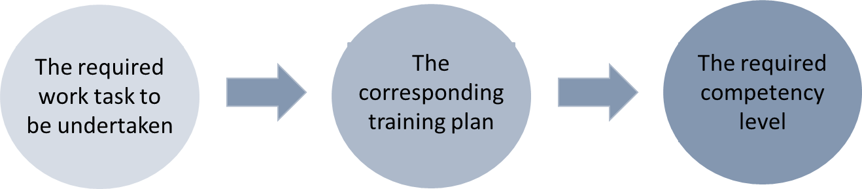

* A logbook can be used by the trainee when approaching employers for a job and companies in a hiring situation, thereby becoming an important instrument facilitating the transition from learning to employment.

**Cons**

* Experience indicates some of the challenges in the use of the logbook for company mentors, TVET teachers and trainees such as:

|  |  |
| --- | --- |
| **Company Mentors:** | * Guidelines of how the performance assessment part of the logbook is not clear * Assessment cannot always be done in time because of tight schedules within the company * Logbooks demand a lot of administrative work |
| **TVET Teachers:** | * Guidelines for assessment are not clear * The logbook demands a lot of clerical work * Mentors complete the logbook in retrospect which may compromise correct recording |
| **Trainees:** | * Assessment using the logbook is subjective * Lack of proper student induction on the use of the logbook * Assessment was not skill-oriented but based on meeting production targets * Mentors were not given sufficient guidelines on how to assess students using the logbook |

Source: The logbook: gaps perceived in assessing students on 'on the job education and training' by [Jumo Cryton](https://www.semanticscholar.org/author/Jumo-Cryton/81555480), [Chakamba John Misozi Chiweshe](https://www.semanticscholar.org/author/Chakamba-John-Misozi-Chiweshe/118320055), [E. Xavier](https://www.semanticscholar.org/author/E.-Xavier/145080315), and [Museva Stenford](https://www.semanticscholar.org/author/Museva-Stenford/113324403) in Journal of Emerging Trends in Educational Research and Policy Studies 4 (2013): 252-257.

* It is interesting to note that many of the challenges with the logbook mentioned are related to the introduction to how to use the logbook and not the logbook itself. This illustrates (i) the importance of making the logbook as simple and self-explanatory as possible and (ii) the tool is only as good as the introduction to its use.
* Challenges to the strength of the logbook’s assessment qualities (‘Assessment using the logbook is subjective’ and ‘Assessment was not skill-oriented but based on meeting production targets’) question the ability of the logbook to meet one of its objectives – namely to assess the learning progress of the trainee. Consequently, it is important to be mindful of how the logbook is designed so it focuses on its assessment qualities by among other things including as many objective assessment criteria as possible. This is easier said than done because any assessment includes an element of subjectivity on the side of the assessor. However, if the assessor should justify the assessment against clear learning goals it may offer just that more to make the assessment as fair and objective as possible.

**Sources**

* Bricklayer - Internship Log Book The National Trade Committee for the Education of the Bricklayer, Stonemason and Stucco Worker Trades. <https://www.bygud.com/education-and-training/educations/bricklayer/logbook/>
* Cryton, Jumo, Chakamba John Misozi Chiweshe, E. Xavier and Museva Stenford. “The logbook : gaps perceived in assessing students on 'on the job education and training'.” *Journal of Emerging Trends in Educational Research and Policy Studies* 4 (2013): 252-257.
* VETA Logbook, VETA
* Packed Curriculum for Welding and Fabrication Short Course. VETA 2013
* Introduction to the eLogbook, the Institute of the Motor Industry in the United Kingdom. <https://www.youtube.com/watch?v=PJzl6tnWJOs>

1. Disclaimer: This publication was produced with the financial support of the European Union and the German Federal Ministry for Economic Cooperation and Development. The views and opinions expressed herein are those of the authors or persons cited and do not necessarily reflect the official policy, view or position of AUDA-NEPAD, the European Union or the German Federal Ministry for Economic Cooperation and Development. The terms used herein and the presentation of material therein do not imply any endorsement by AUDA-NPAD, the European Union or the German Federal Ministry for Economic Cooperation and Development. Information in this book is offered in the understanding that it does not contain legal, financial or other forms of professional advice. Although the author has made great efforts to ensure the accuracy of the content, errors and omissions may occur.